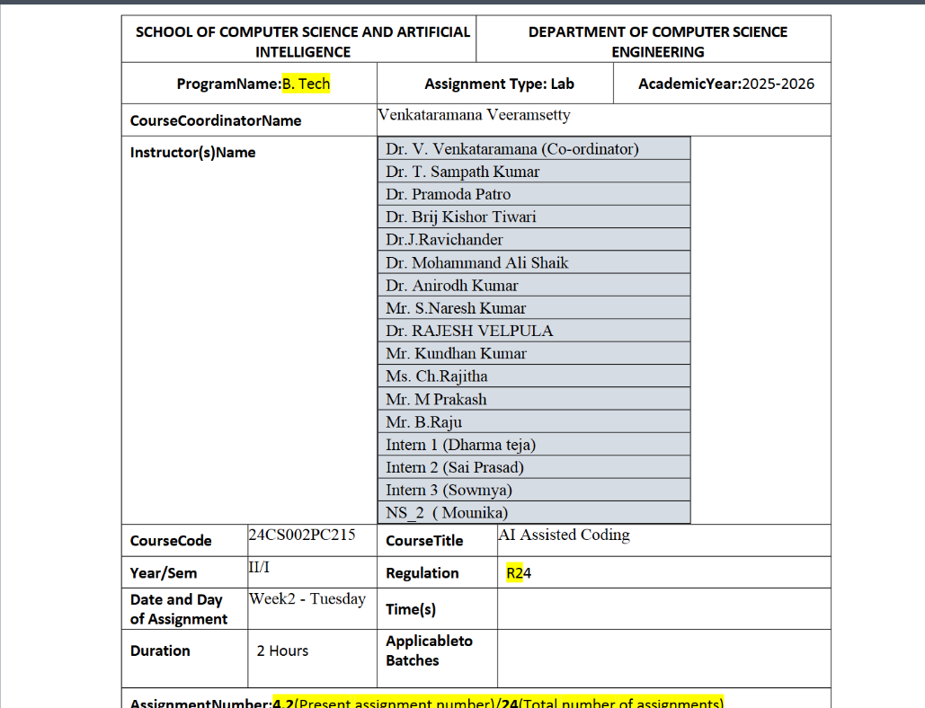

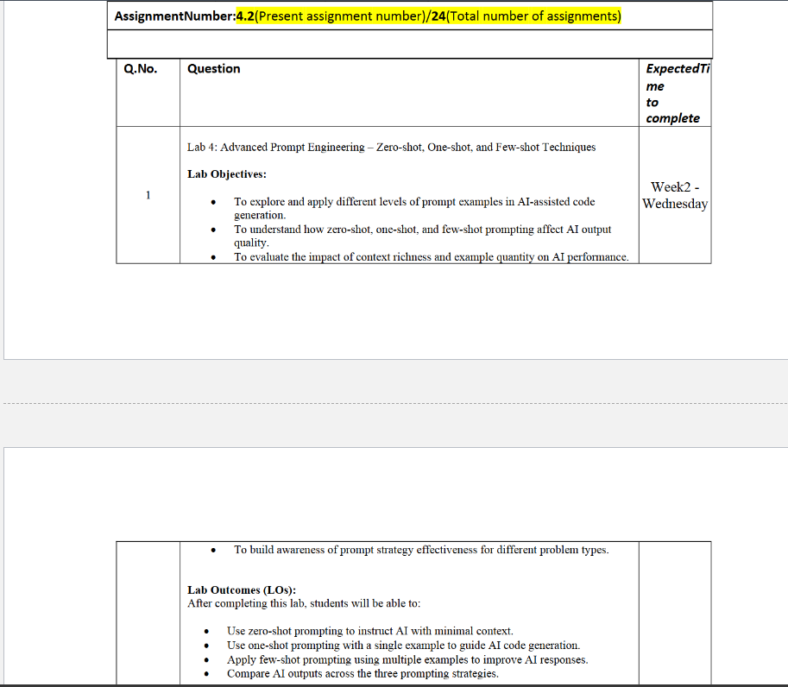
Task Description#1
• Zero-shot: Prompt AI with only the instruction — Write a Python function to
generate the Fibonacci sequence up to n terms
Expected Output#1
• A working function without using any sample inputs/outputs
CODE:
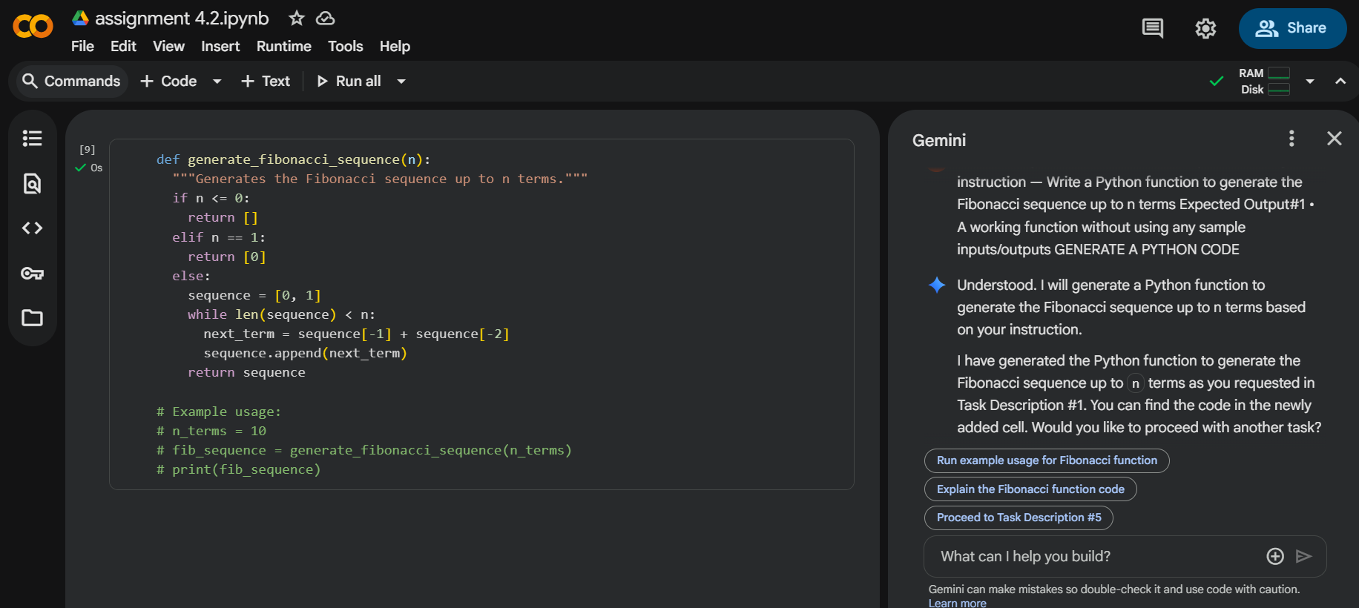

Task Description#2
• One-shot: Provide one example: Input: 100, Output: 37.78 to help AI generate a
function that converts Fahrenheit to Celsius.
Expected Output#2
• A correct conversion function guided by the single example
CODE:
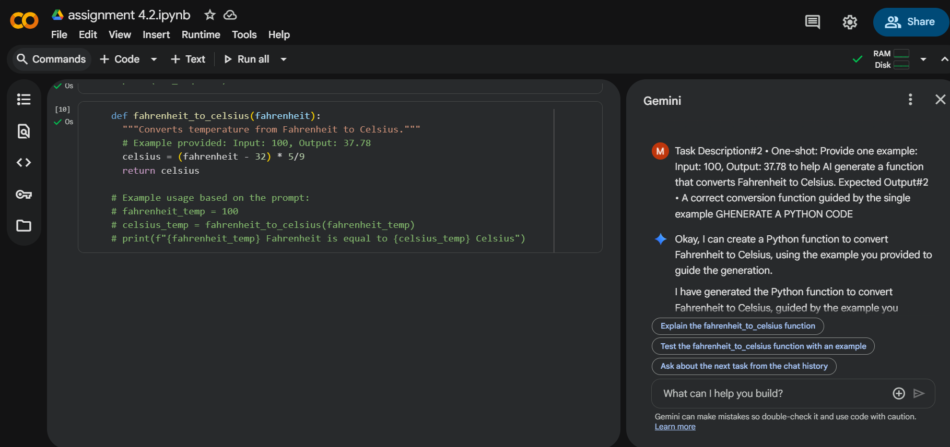
Task Description#3
• Few-shot: Give 2–3 examples to create a function that extracts the domain name from
an email address.
Expected Output#3
• Accurate function that returns only the domain portion of an email (e.g.,
@gmail.com)
CODE:
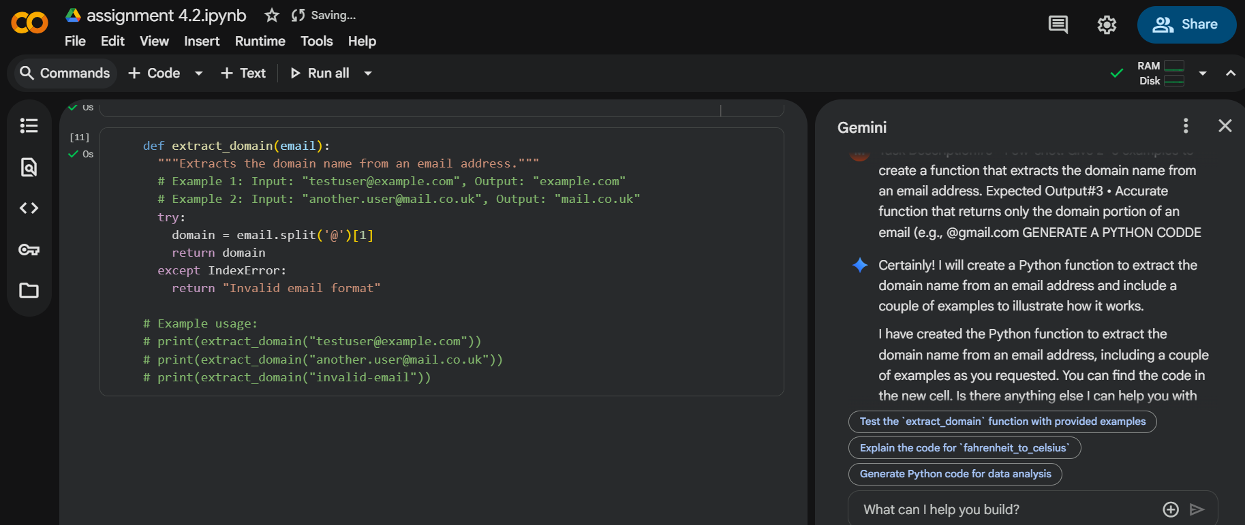
Task Description#4
• Compare zero-shot vs few-shot prompting for generating a function that checks
whether a word is a palindrome, ignoring punctuation and case.
Expected Output#4
• Output comparison + student explanation on how examples helped the model.
CODE:
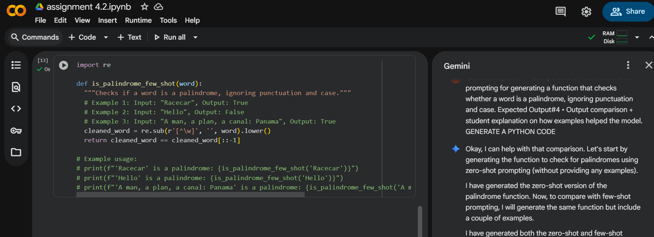
Task Description#5
• Use few-shot prompting with 3 sample inputs to generate a function that determines
the maximum of three numbers without using the built-in max() function.
Expected Output#5
• A function that handles all cases with correct logic based on example patterns.
CODE:
